Name of Student: HARPAL BIDAWAT | PRN:25070122080
Semester: III | Year: AY 2026-27
Subject: Programming with Java
ASSIGNMENT No: 29
TITLE: Write a JSP application to demonstrate the basic concepts of Java Server Pages.
Problem Statement
Write a JSP application to demonstrate the basic concepts of Java Server Pages.
Learning Objectives
To develop dynamic web pages using Java Server Pages.
Programme
1. Create a JSP page to display student information entered by the user
2. Create a JSP application that takes user registration details such as Name, Email, Phone Number, and Password, and displays the submitted information on a result JSP page.
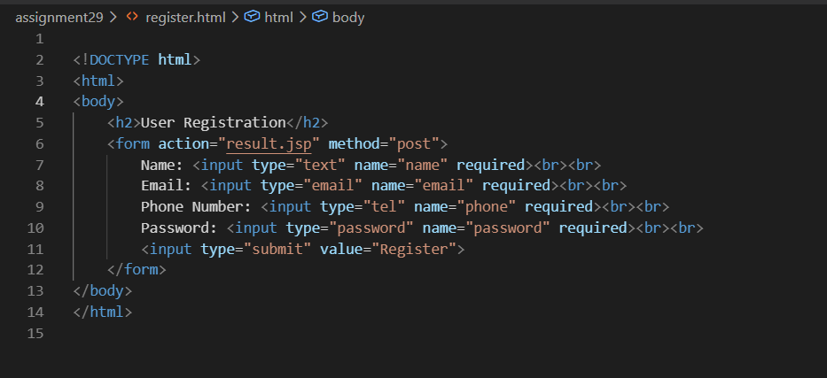
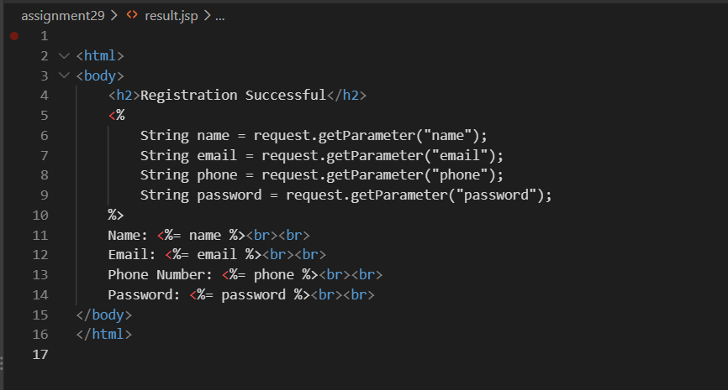
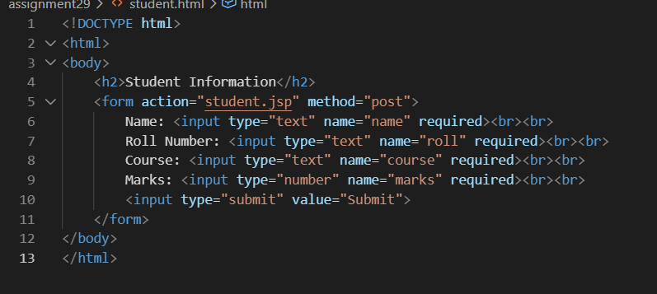
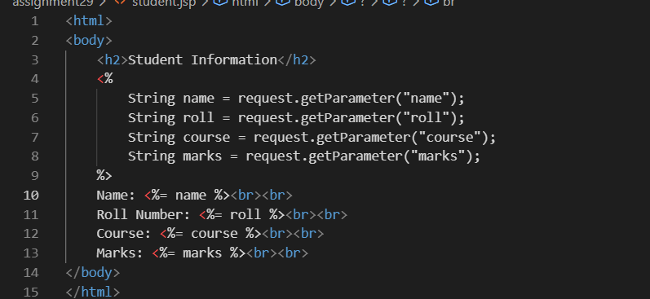

Output

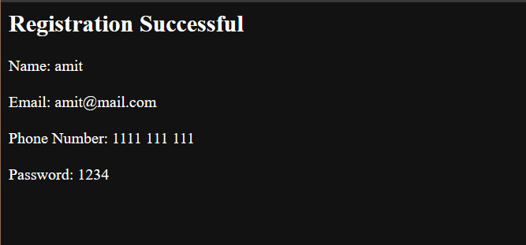
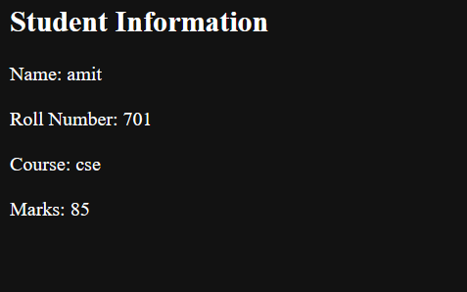


Conclusion
The programs successfully demonstrate JSP form handling and dynamic web page generation. The first program accepts and displays student information, while the second collects user registration details and displays them on a result page.

